**Client**

There is a newly opened noodle restaurant named “No.1 Noodle House” in Ottawa. They focus on making a variety of traditional and classical noodle cuisines from many different regions. Whether you are looking for spicy or non-spicy noodles, dried noodles or noodle soup, instant noodles or Japanese ramen, you will find one of your favourites here. The restaurant is aiming to provide the best noodles for its customers. The restaurant owner is the **client** who wants to create a website to let more people know about the restaurant. People can also see featured food, menus, opening hours, contact details on the website.

**Style**

The website should be comfortable, stylish, and eye-catching. People who have never been there will have a warm and comfortable feeling by looking at the website. They will associate it with warm hugs and homemade hot soup in winter.

When people open the home page, they will be greeted with food photos that look especially delicious and eye-catching. It gives people a desire to scroll down to see what’s in the restaurant. The website will use a lot of pictures and a little text surrounding them, which gives a simple and clear impression.

**Platform**

We assume that our client would like to build a website for users on traditional laptops and computers. The website will target traditional monitor resolutions of 1024*768 and greater. The website will be opened with Chrome or Microsoft Edge browser. These broswers support web safe CSS font stacks such as ‘Candara’, 'Lucida Grande', Geneva, Verdana, sans-serif, which will be used on our website.

**Semantic Design Guide**

|  |  |  |  |  |  |
| --- | --- | --- | --- | --- | --- |
|  | header | nav | main | section | footer |
| Expected use | Used for the top matter of the website which includes company’s logo and navigation bar | A navigation bar is used to link all major pages on the website | Show only one main content of the page | Used to group contents of similar theme | Used to include company’s logo, contact, address, and opening hours |
| Name(id=) | logo | / | / | Section1, section2, section3 | Logo2, verticalLine |
| font | Candara | Candara | Candara | Candara | Candara |
| color | Background-color: #810202  Color: #eee3c7 | Background-color: #810202  Color: #eee3c7 | Background-color: #9c0303  Color: whitesmoke | Background-color: #9c0303  Color: whitesmoke | Background-color: #810202  Color: #eee3c7 |
| Image&size | logo  height: 120px; | / | landingImage, landingImage2 (height: 100vh),  bgImage (height: 100%) | landingImage, landingImage2 (height: 100vh),  bgImage (height: 100%) | Logo2  height: 100px; |
| Layout location | at the top of each page | At the top of each page inside header | Right after header and before footer | Inside main part of the page | at the bottom of each page |

**Mockup of Landing Page**

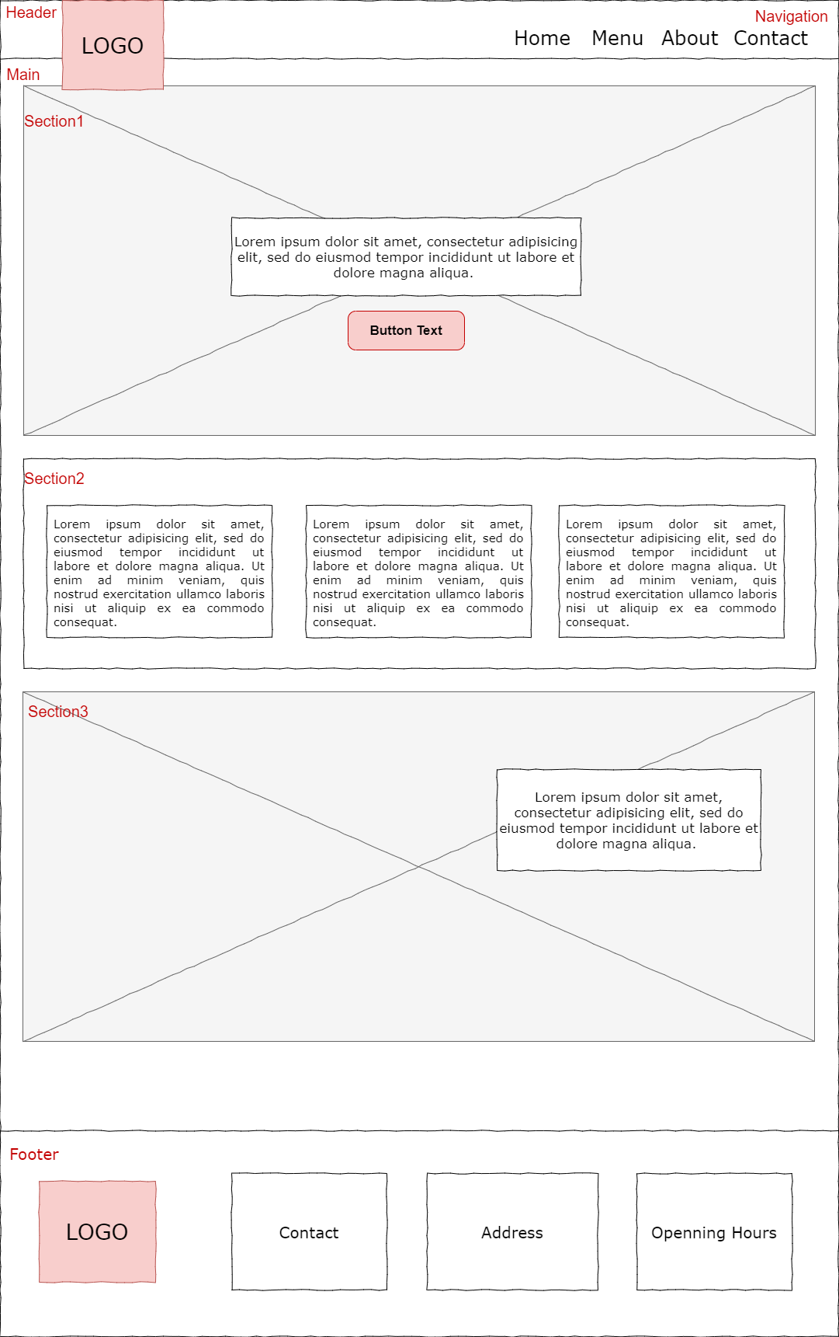

**Website Map**

